Your source for eBooks at the Smithville Public Library!

Here are some brief instructions for accessing OverDrive on the most common mobile devices – iPad/iPhone/iPod Touch, Kindle, and other Android tablet devices. If you are using your computer to access OverDrive, skip to Step 2.

Step 1: Downloading and Setting Up the OverDrive App
Open the App Store on your mobile device and search for the free OverDrive Media Console app (the icon will look like the image at the top of this page), then download it to your device. When you open the OverDrive app for the first time, follow any instructions or prompts given to you to complete the installation process. Part of the setup may require you to set up an Adobe ID, which you will need to download books from OverDrive.
NOTE: If your device does not have wireless capability, like the NOOK and other early eReaders, you will need to follow instructions to download any materials on your computer, then hook your device up and sync it with your downloaded books.

Step 2: Finding Your Library in the OverDrive Catalog
You can access the OverDrive catalog in two ways: by using the app you downloaded, or by opening your device’s Internet browser and viewing the Central Texas Digital Library catalog.
OverDrive App: Open the OverDrive app, then swipe your finger from left to right on the screen to open the Home menu. Tap Add a library, and search for our zip code (78957) and select the Smithville Public Library. Then tap Central Texas Digital Library, and you will see a home page for the catalog. Sign in to your account by tapping the button in the top right corner, and select a library from the drop down menu. You will need your library card number (include all zeroes!) and password (10 digit phone number listed in our records).
NOTE for Kindle users: To download an eBook in Kindle format, you will be asked to sign in to your Amazon account.
Internet Browser: Connect to a Wi-Fi signal and get on the Internet, then go to ctdl.lib.overdrive.com. Click the Sign In button in the top right corner of the home page. Type Smithville Public Library, then enter your library card number (include all zeroes!) and password (10 digit phone number listed in our records).

Step 3: Borrowing an eBook or Audio Book
Once you’ve signed in to the OverDrive catalog, you do not need to repeat the above steps unless you sign out or delete the OverDrive app from your device.
Search for the title or author of a book or audio book in the catalog, and then tap the item you’d like to borrow. If the item has a bold icon in the top right corner, the title is available and you may tap the Borrow Book button to begin downloading the material immediately. If you see a gray icon, the book is currently checked out but you may tap the Place a Hold button and you will be able to download it when it is available.
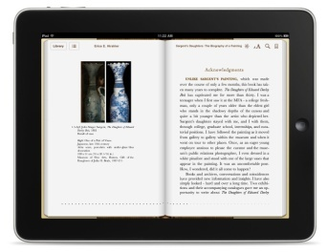
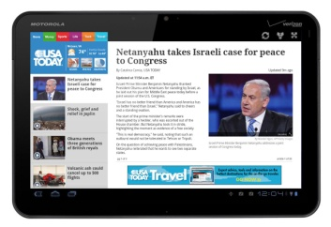
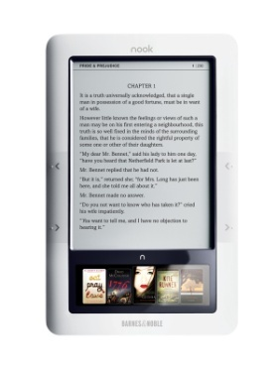
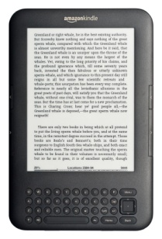
NOTE: Make sure to select a format appropriate to your device, e.g. a Kindle version of the book if you are using a Kindle.

If you have any additional questions, check the following resources for thorough instructions:
Step-by-Step Instructions for Your Device: http://help.overdrive.com/
List of Compatible Devices: http://www.overdrive.com/drc/
Or, you can call us here at the library (512) 237-3282 x6, or visit with us and we’ll do our best to get you on the road to using OverDrive and accessing our digital collection.
Thank you for supporting and experimenting with us as we explore the world of electronic materials!

